Coover Presentation
Slide – Uncle Walt
I would like to introduce the host for our presentation, Walter Lee Kauffman. On August 9, 1860, in the Ivy House, located on the other side of that wall, Walter Lee Kauffman, was born to the family of Ann Elizabeth Coover and Levi Kauffman. Uncle Walt, my great uncle, was the second of three children; his brother, Percival Coover Kauffman was my grandfather and little Edith Belle Kauffman was the youngest. I never knew my grandfather. He died when my Dad was 17. Nor did I know Aunt Edith. But Uncle Walt, I did know! As a child, he would come to our house from nearby Youngstown, decked out with a straw hat and dressed to the nines as my aunt would say.
The Coover/Keller/Kauffman families occupied this town and the surrounding areas back as early as the 1700s coming as part of the religious migrations from Switzerland and southern Germany fleeing persecution of the Catholic French and settling from Philadelphia west.
Slide Coover Home
Slide Coover Home
John Coover and Salome Keller Coover lived in this house, part of the 3rd generation of Coover’s in this area.
Ann Elizabeth was one of five Coover daughters. The first born child, a boy died in infancy. The daughters, Sarah, Susan, Emma, Mary Anne, and Anne Elizabeth all lived in this house. Sarah married a Zug, Emma, another Coover, Mary Anne married a Hummel. Ann Elizabeth married a Kauffman. Susan married a Long. This left the family of John Coover and Salome Keller Coover with no male heirs.
Her granddaughter, Harriet Armstrong and I corresponded for many years, most recently about 1985 when she wrote me that she had often returned to Mechanicsburg to visit the family cemetery, Barbace, but during her recent trip, she was unable to find it and feared that it had been plowed under during the construction of some factory buildings outside of town. She asked me to help find Barbace.
Well, my Uncle Walt, had been quite a family historian. He had trunks full of stuff and books and pictures galore. My mother having noticed that I had an interest in this stuff, had given it to me after we were first married along with about 80 boxes of old books and 78RPM records. So, we hauled them from place to place until we finally ended up in a house where they ended up in the basement unopened as we raised our family.
Slide – Coover House
Now I had a picture on my wall of the Coover house, but did not know quite where it was.
Slide –Barbace Cemetery
And I had pictures of Barbace cemetery. I knew of Mechanicsburg. Uncle Walt was buried here. And we lived outside of Washington DC. I did a bit of research and spoke to my friend who was a lawyer and I learned that there were laws protecting cemeteries. Also I knew that Uncle Walt had purchased some land, I thought, that might include the cemetery. So, I sought out a local attorney to help and then started digging in the boxes. Quickly we established that the cemetery still existed. Harriet simply got lost and because the cemetery was private and not maintained, it had been overgrown with weeds and trees and was hard to find.
But the hook had been set. I had opened the chests and quickly discovered some of its many treasures which I will share with you today.
So, as soon as the dust settled, I scheduled a trip to Mechanicsburg to discover my family roots, only to discover that Mechanicsburg knew all about the Coover’s and the Kauffman’s and Barbace and the historic homes and cemeteries. I arrived on Main Street on a nice fall day and knocked on the door of the Coover House. I was invited in and got a tour.
Before the day was over, I had spoken with Eva Williams, who had compiled a list of the Homes of Mechanicsburg, a wonderful digest of homes and histories. I spoke to Steve Zimmerman of the Mechanicsburg museum, Fern Oram, and had the names of Marty Coover, David and Vicky. Someone gave me directions to Barbace and I was off and running.
I drove down Main Street, then over to Coover Street and Keller Street, enjoying the old family names that I had heard about all my life. I started out E Main Street, then down N Walnut and over to Brandy Lane. There I found the Brandy Lane Trailer Court. I drove down to the back and climbed thru the rubble and found Barbace, our hidden cemetery, run down but largely intact.
Before I continue my story, let me share with you some pictures of the original furniture from the Coover House.
Slides – Coover furniture
Slide – Keller Family Tree
The Keller’s were another early family of Mechanicsburg. Martin was born in Switzerland and married Barbara Verts of Basel, Switzerland. Her father was mayor of the town. Martin came to Baltimore in 1785 when he was 18 years old. He worked in his trade as a turner on Gay Street. He moved to Manheim where he married Salome Mohler daughter of John Mohler, son of Henry and grandson of Ludwig. They moved to Barbace in 1802 in Silver Spring Township. He purchased Barbace from Simon Grouse in 1810. It was 246 acres.
Slide – Barbace Farm
The origin of the name Barbace is unknown but the farm encompassed most of the land from Salem Church Road, and along Brandy Lane. Here are some interesting things from the Keller history.
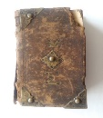
Slide – Hymnal 1787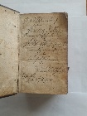
Slide – Chest of Ludwig Mohler – arrived on the Thistle
Slide – Birth Announcement Suzanna Kellerin
Slide – Barbace Cemetery
The farm was eventually owned by John Coover and given to his daughter, Mary Ann Coover Hummel. The cemetery was deeded separately when the surrounding land was sold to outside interests and eventually to Ralston Purina. Uncle Walt purchased a strip of land from Brandy Lane to the cemetery from Ellen Hummel in 1930.
Slide – Barbace over time
Many of the people buried in Barbace are related to the Coover’s and Keller’s. I have many pictures of the cemetery over time. You can see the small trees grew into large ones and eventually were cut down. Most of the stones have been broken or destroyed but a few are intact and every time I come I see flags and flowers so the families of the deceased are still here in Mechanicsburg. The first person buried in the cemetery was in 1806 so apparently it existed as a cemetery before Keller purchased the farm. It had been purchased in 1762 by Christopher Seeley. This deed references the cemetery 80 by 40 feet.
Both John Coover and Salome Keller Coover are buried here. Also, John reinterred` his parents and grandparents at Barbace.
Burials at Barbace include:
- Martin Keller and family
- Hanna Bosler. Daughter of Martin
- John Kober, Elizabeth Mohler
- John Dieterich (Kober) Coover, Anna Dieterich Kober Coover
- Other families
- Henaman
- Neiswanger
- How
- Hunsberger
- Kensey
- Riegel
- Utz
- Webert
- Baker
- Howard,
- Buser
A total of 39 people. The last person buried there was Salome Keller Coover in 1883. In 1892, upon the settlement of the Coover estate and sale of this property, there was a stipulation that there will be no more burials here at Barbace.
Uncle Walt always wanted to restore this cemetery. Perhaps…

Harriet Long wrote many interesting facts.
“In Mechanicsburg, the Salome Keller Coover house is on the right hand side of the street as you go west, about a block from the main intersection of Main and Market Streets. Robert Miner, once editor of Early American Life, lives there. When the house was being remodeled, you could see the log structure, Then this was covered with wide brown siding, It is supposed to be the oldest house in Mechanicsburg.”
“At Main and Market, across from the Mechanicsburg Bank, which is now part of PNC, is a frame store front with an apartment above, badly in need of paint, the last time I saw it. Susan lived there when my mother was a little girl, perhaps after Dr. Long died. Dr. Long one time had a drug store downstairs. Then they passed the law that doctors could not have drug stores so they gave it up. “ Interesting, Levi Kauffman came here as a druggist and worked in this store.
“For my mother, as a child, a treat was to go to Rakestraws for ice cream on Market Street. A disgruntled employee burned it down but they rebuilt it. “
“My son went to Lehigh. My mother asked him to call on the Zug’s in Bethlehem, who were relatives of Salome Keller Coover. He never did. My other great grandfather was Levi Merkel, was co-founder of the Mechanicsburg Bank with a man named Mumma. The founding of the bank goes back to the Civil War.”
So who are the Coover’s?
John Dieterich Kober, Palatine immigrant, was born in 1703 somewhere in Germany, or Switzerland. He was descended from the German family “Kober” afterwards changed to Coover who immigrated to this country in about 1730. He arrived on the Thistle. He settled in Lebanon county, then Lancaster, county, PA. Soon after this date, Coover bought a large tract of land, being part of the “Manor on Conodeguinet” situated by the Cedar Spring, south of Shiremanstown, Cumberland County PA. He had nine children. (John) George Coover was born on January 27, 1741. He was married on October 22nd 1764 to Elizabeth Mohler. George purchased a plantation at Cedar Spring. They had ten children, of whom John Coover was the youngest. Another son, Gideon Coover owned parts of this property and is buried at St Johns cemetery near there.
Everyone knows where Shiremanstown is? Along West Main Street near the intersection of South Locust? And the Manor on Conodeguinet? Perhaps just over Route 11 along Orrs Bridge Road.
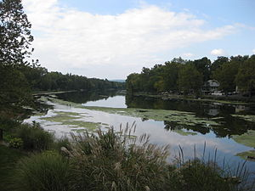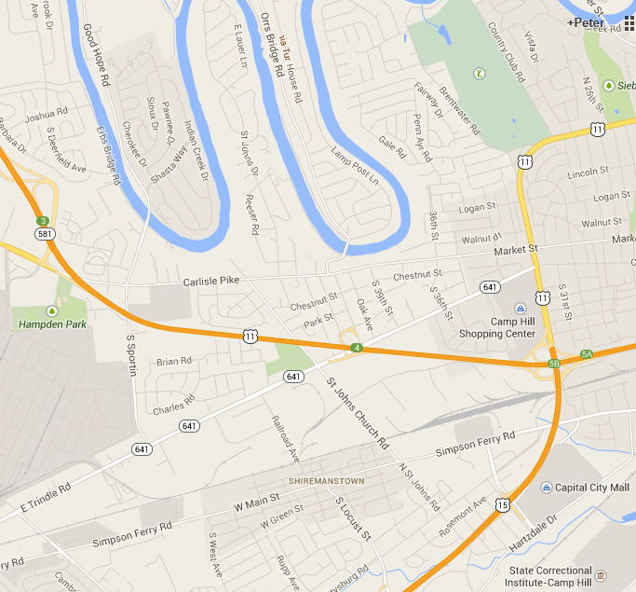
The story of George Kober and Elizabeth Mohlerin is interesting.
Slide – Only a few practical little things
It seems that Elizabeth was the daughter of Ludwig Mohler. The “–in” affixed to the last name reflected that she was the unmarried daughter. Now if you are from Ephrata, you certainly know the name Mohler. He was one of the founders of the town and over there, everyone is trying to show that they are related to old Ludwig. Anyways, Elizabeth was betrothed to another man.
This letter from Anne Elizabeth Coover Kauffman, my great grandmother, titled "A skein of linen thread" is in my possession along with two skein's of thread. _______________________________________________________________________
I have no regal jewels, nor magnificent "purple and fine linen to show you, only a few practical little things which suggest the everyday life of my forebears.
The first is only a little skein of linen thread - “surely there is nothing in that" you say - ay, thereby hangs the tale.
On the banks of the Cocalico Creek in the far famed Ephrata, in the County of Lancaster, and the state of Pennsylvania — there lived a maiden. Tradition says she was born in 1744 and was very beautiful — but are not all heroines beautiful?
Bright, active and industrious, as was the custom in those early days, she like all dutiful daughters learned to knit, to sew and to spin, thus helping to lighten the household duties.
As she grew into young womanhood, as was the custom of the time, she daily spun a certain amount — there being an amiable rivalry between the sisters as to who could spin the most in a given—time. Thus daily she would sit and spin the flax grown upon her father’s farm — and who can tell the happy thoughts that flitted through her brain, as day by day she drew the flax through her tiny fingers into a web—like thread? Doubtless many thoughts and dreams were of the lover forty miles away.
With deep forests to pass through, the broad Susquehanna River to cross and Indians to avoid, forty miles meant far more than the forty miles of today - which may be covered in little more than half an hour. 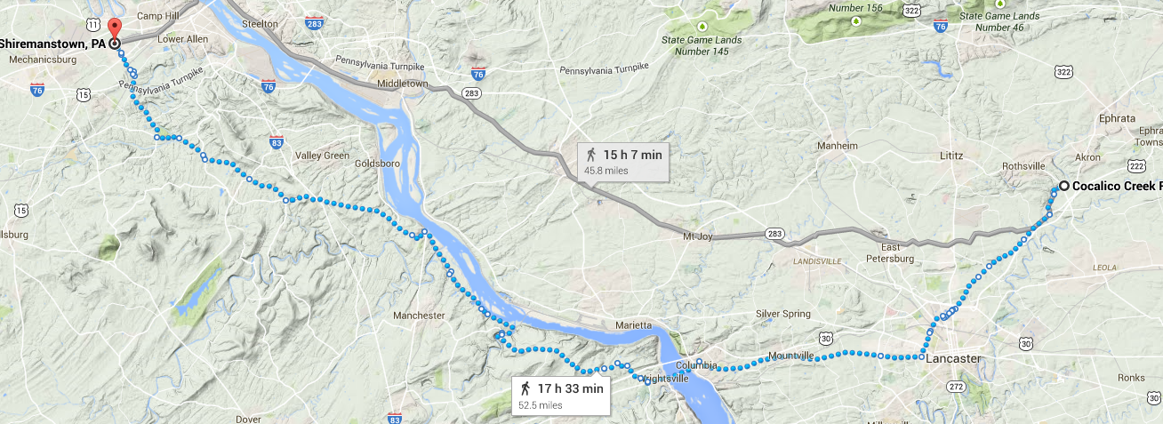
Months passed - the proverbial chest to which all daughters belonging to German families, is entitled, was filled to overflowing with household linen. The finest of thread, serving to make many stitches thereon - This is some of the thread spun by that maiden at that time.
Later a trousseau was prepared - the wedding day was set. The twenty-fourth day of October, l764 was to be the happy day. A great feast was prepared for the morrow — for many guests were bidden to this wedding — from far and near which they expected, hence the great preparations. But who can tell what a day may bring forth?
Remember in the eighteenth century no telegrams were even dreamed of, no telephones thought of. Nor were there any railroads nor autos, no bicycles, not even horse cars, - so news traveled slowly, or some might have been spared embarrassment.
The day appointed for the wedding dawned - a bright, beautiful day in October - and with it came the bidden guests - there came too, an expectant bridegroom, but where was the bride? - there was no bride - the maiden had fled.
Tradition says, "that during the night previous - the man of her choice rode on horseback quietly up to the house, at the signal previously agreed upon, the maiden stealthily left her fathers home for the arms of her lover. Hastily they rode to the town of York, twenty miles away, and were married.
I am now in possession of their marriage certificate for it was my paternal grandfather who carried off the prize- and took her to her new home which was at Cedar Spring, Cumberland Co., Penna.
My grandmother’s name was Elizabeth - I never saw her. I bear her name, but fear I am minus her better qualities - of one thing I am sure, I never would have had the courage to elope - The chagrin or the disappointed lover we may imagine. This bit of thread, as l said before, was part of what she spun before her marriage.
She gave it to another granddaughter my cousin Sallie Coover, when she was yet a Child only ten years old. Cousin Sallie was very fond of telling this story, and when she reached her hundredth birthday she divided this thread into different parcels, tied each with a bit of ribbon; as you see and gave a “parcel" to each of her favorite cousins - of whom I am happy to say, I was one. When one hundred and five years old she told me this story again. Last March at the age of one hundred and six years, this cousin "went to sleep."
A. E. K. November 1904
Grandfather - George Coover
Grandmother - Elizabeth Mohler Coover
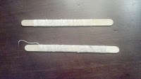
Here is their wedding license. It says "I Nicholaus Hornell, Minister of the high German Lutherean Church of York town in York County, do hereby certify to whom it may concern that George Kober and Elizabeth Molerin, were lawfully joined together in the holy matrimony and pronounced man and wife on the 22nd day of October, A.D. 1764. By me, Nicholaus Hornell"
On the back of the marriage license, Uncle Walt has written "Marriage Certificate of my Great Grandfather, Hon. George Kober (Coover), Oct 22, 1764. Father of John Coover, my grandfather, born Feb 22, 1784. 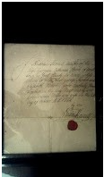

Linen Bag's and more
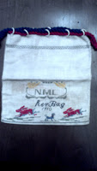
There was a note with the linen bag.
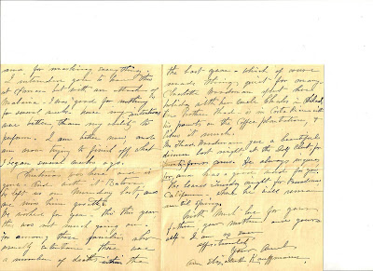
You can see the signature of Ann Elizabeth Kauffman at the bottom. In this note, Ann says that the flax that is used to create this bag was grown at the farm "Barbace", from which the cemetery was named. The date, 1803 is a date associated with Salome Keller but interestingly she was born in 1792 and died in 1883. The date 1910 was when Ann Elizabeth created these bags. She was 79 at the time and died the next year.
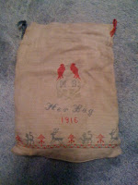
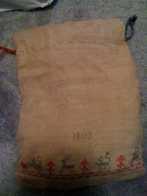
Notice that the bag has the initials MB and the dates 1803 and 1915. I assume that 1915 is when the bag was made. I do not know the significance of the 1803 date but we will continue our research. I have one last piece of linen.
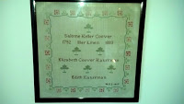
This has the name of Salome Keller Coover, the mother of Ann Elizabeth and the dates of her birth 1792 and death 1883. It has the name of Ann Elizabeth who went by Elizabeth Coover Kauffman. And it has the name, Edith Kauffman, who of course is our great aunt, Edith Belle. Also it has the initials of MVZ and the date 1927. This is when it was made. Just who is MVZ? Well, the hint is the Z. That would be the Zug's. One of the Coover sisters, Sarah, married Harry Zug. Their son Charles Keller Zug married Marietta Veasey. So this is Marietta Veasey Zug.
Slides - Kauffman Family Tree
Uncle Walt, his younger brother Percy and little Edith grew up in the Ivy House, next door. The door kept them under the thumb of Mother Coover.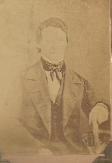 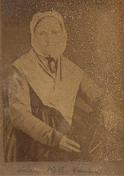 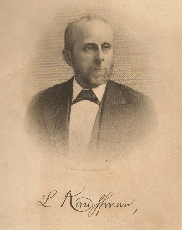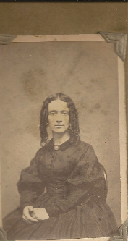
The boys were entrepreneurs from the start. Summit Gardens was one such venture. 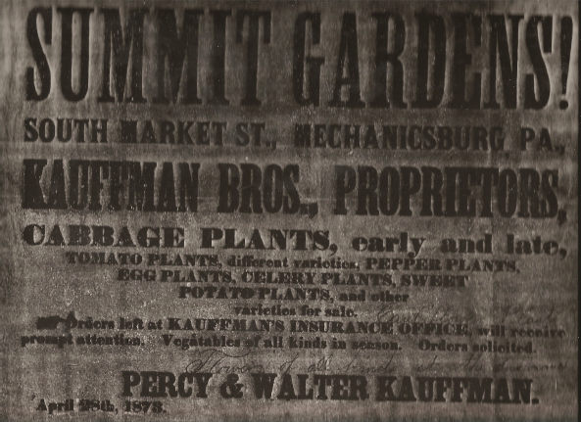
Uncle Walt went on to Dickerson, then eventually moved to Youngstown with his sister, and after retiring at the age of 82, lived to be 94, but never married. Edith was very active in women’s organizations and has a city park which she was instrumental in creating named after her. 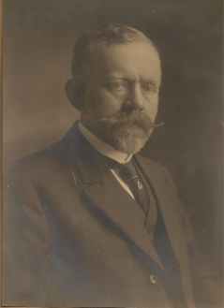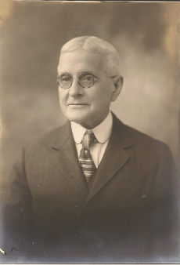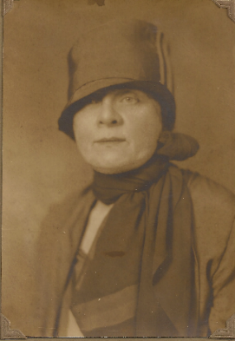

Percy, my grandfather, became a lawyer and banker, married Katharine Barton of Hazelton and moved to Vancouver WA and then Tacoma where he started a bank with his uncle.
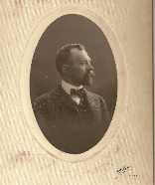
He died when my Dad was 17. The Kauffman’s are all buried in Chestnut Hills Cemetery, east of town.
My Dad was born in 1895, Walter Lee Kauffman 2nd.
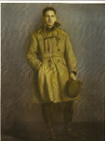

The Kauffman’s came to Mechanicsburg in the 1850s. Mennonites from Manor Township in Lancaster County, they had had enough of farming and the strict doctrines of the Mennonite faith and left after five generations. Levi was born to Andrew Isaac Kauffman and Catherine Shuman. Levi was educated as a pharmacist and served his apprenticeship in Elizabethtown, PA until 1854 when he came to Mechanicsburg and opened a Drug Store. The next year he expanded the store with a hardware store with his father, Andrew who had moved to Mechanicsburg, and Henry Rupp. He joined the bank with Merkel, Mumma and Company in 1859 then became a tax collector under Lincoln. He died in 1882. 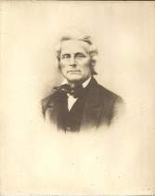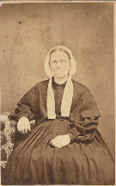

I never knew all of this but as I pulled stuff out of those trunks, I found a vast treasure of Kauffman genealogy dating back until the 1500s of the Kauffman’s in Switzerland. They were mayors and councilors, Bailifs and Secretaries. There was a coat of arms and a castle on Lake Geneva where it hung in the great room along with the other great families. But why did they come to America?

Well, welcome to the history of the Mennonites. According to Uncle Walt’s research, the Rev Isaac Kauffman had been exiled to Holland where he was recruited by William Penn to bring a group of Mennonite families into Pennsylvania. This was the second wave after those who settled in Berks County. Isaac Kauffman and others led a group into Manor Township outside of Lancaster along the Susquehanna River in the early 1700s.
I started some research with the archives in Harrisburg. I also found a book, Kauffman-Coffman Linages at the Mennonite Library east of Lancaster.
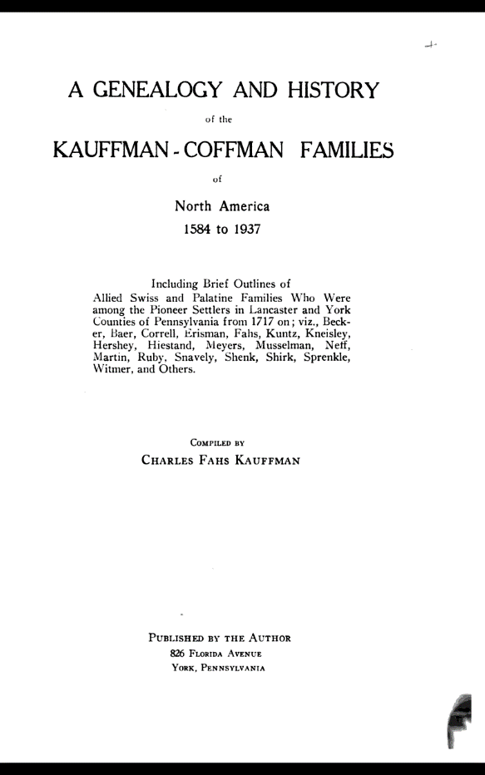
From the book, I found a sketch of a settlement along the Lincoln Highway (old Route 30) where Isaac had settled.
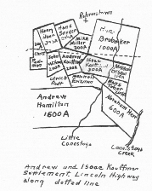
With the archives, I found the full map of the grants to the Mennonites that settled in Manor Township.
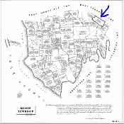
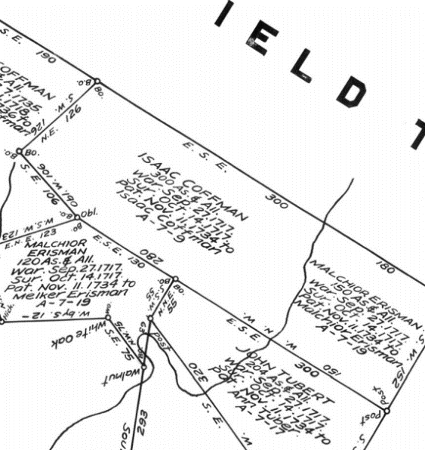
But getting from A to B is not that simple. Looking at a modern map, I was able to guess that the Kauffman land grant was somewhere near a park.
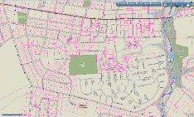

In my earlier blog I spoke of the land of Isaac Kauffman, granted under a warrant shown on the map. This farm exists today and is owned by Jere Dickerson. I met Jerry as part of my quest as I visited Lancaster in 2012. The story was quite fascinating. I had gone to Ephrata, some 30 miles north of Lancaster to visit the historical society and subsequently the home of Ludwig Mohler. If you recall the story of Elizabeth Mohlerin eloping with John Coover back in early 1800s, something unheard of for Mennonites, this is her home.
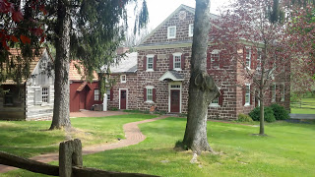
Having successfully located this farm, I set off shortly after noon for a brief trip down to a park which is described in that story. Well, I saw the remnants of an old barn and beyond I saw an old farm house. Being bold, I went to the door and knocked. This old gentleman came to the door and opened it, looking skeptically at me. I said my name and that i was traveling thru the area and was looking for the Kauffman Farm. He said, "Well, you found it, come on in." The story and tour were amazing.
He had purchased the farm some 20 years prior and restored it. He took me throughout, showing me the construction, the expansion, the Indian Door that had slits so you could fire out without exposing yourself to harms way. In the basement he had gravestones with Kauffman's listed. He explained that when the developers cut up the old farm they wanted to plow under these stones. He rescued them and kept them in the basement. This home was built by Andrew Kauffman in 1756, one of the son's of Isaac Kauffman. Adjacent was his workshop and what we believe was the original Isaac Kauffman house. Remember that Isaac came here in 1717. And there is a spring house, where the original spring still exists. I drank of this water, an exciting and emotional event when you think that that is the same water that our ancestors drank of almost 300 years ago. 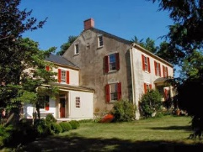

After some research, I determined that Isaac Kauffman was buried adjacent to the Mennenite meeting house less than a mile away. Unfortunately the meeting house had been destroyed and the cemetery plowed under. The Lancaster Mennonite Society had done some research and published a paper, “Plotting the Story of The Abbeyville Mennonite Meeting house and Cemetery” laying out what had happened and showing the approximate location of the cemetery.

So, I knew where Isaac lived and was buried and where his great grandson Andrew and great great grandson Levi lived and were buried but not where his son Christian, or his son Isaac Bear. From my Kauffman Linages book I had a clue, 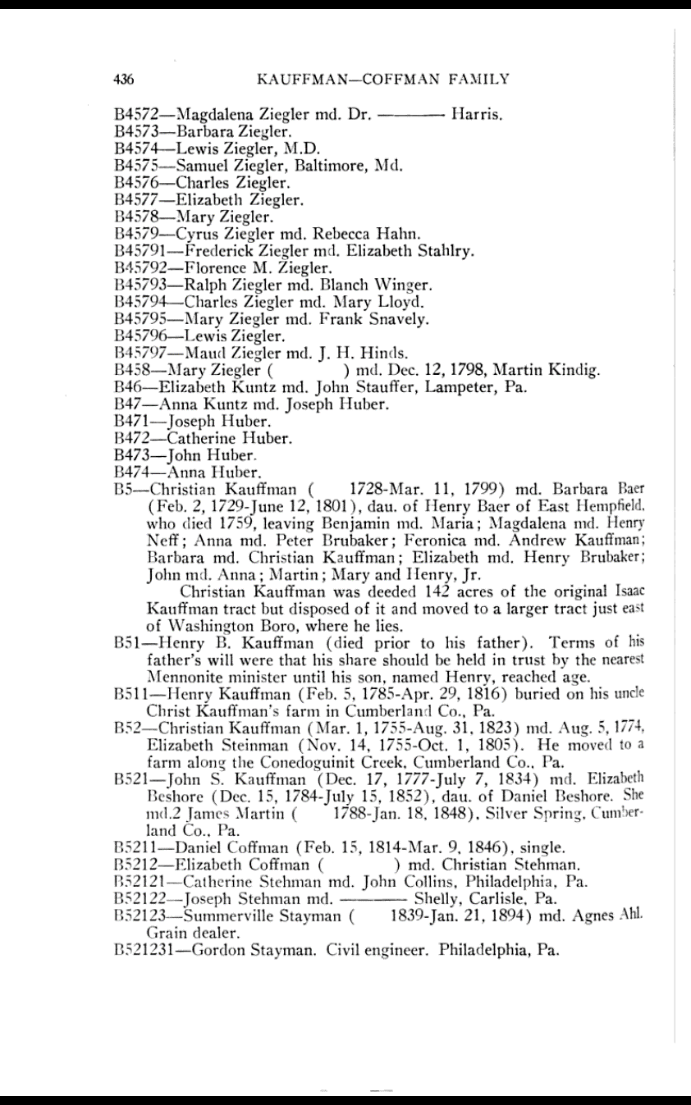
Christian Kauffman was deeded 142 acres of the original Isaac Kauffman tract but disposed of it and moved to a larger tract just east of Washington Boro, where he lies.

Great! But where. I spent hours and hours at the Lancaster archives searching for deeds and finally located some deeds listing Christian and Isaac Baer Kauffman. But if you have ever looked at early deeds, you would see the problem. Today, we have GPS, then we had piles of stones, oak trees, other people’s property who were no longer around. We had perches which was an area or a length used originally by the Romans and French and more recently by the English. A perch as 10 feet. Originally it was 1/10 of the range of an arrow. But then could be 16 ½ feet, 18 feet, 24 feet or even 5 feet. It was also used for areas and volumes. As a survey measurement, it was standardized in 1607 as one fourth of a chain or 16 ½ feet.
On my deed, it described the land as…..
S At a black oak on the corner of the Hans Brubaker tract, began the Andrew and Isaac Kauffman tracts, the Andrew Kauffman homestead beginning at the corner marked by a black oak, thence W.N.W. 190 perches (16.5 feet) along Michael Miller Bare's land W'S.W.60 p. to a post at John Witmer tract; thence along Witmer tract and vacant land SSE 284 p. to a hickory marking corner of Melchicr Erisman tract, N .N .W. 123 p. and along same to corner black calc of Isaac Kauffnan; thence NNW, 106 p. along Isaac Kauffman tract to a black oak; thence N.E. 126 p. along Isaac Kauffman tract to beginning point, containing 200 acres. Isaac Kauffman tract begins at black-oak corner E.S.E. along Hans Brubaker 300 p. thence S. along the various courses of the Little Conestoga Creek, 160 p. on Hans Tnhcr line; thence W.N.W. along lines of Tuber and Erisman 300 p. to corner of black oak of Erisman and Andrew Kauffman’s tracts; thence along Andrew Kauffman’s tract two lines (see above) to beginning of black oak: area 300 acres. Hans Brubaker tract beginning at bIack—oak corner of Kauffmans and Michael Miller, E.S.E. 480 p. to a hickory at Erisman corner; thence N.N.E. 354 p., then NNW 480 p.; thence S.5.W. 354 p. to black oak beginning point; area 1000 acres. You get the idea. Hopefully those Black Oak and Hickory trees are still there.o I found a deed with property described as:
So I drew a map of the land. It looked like this. 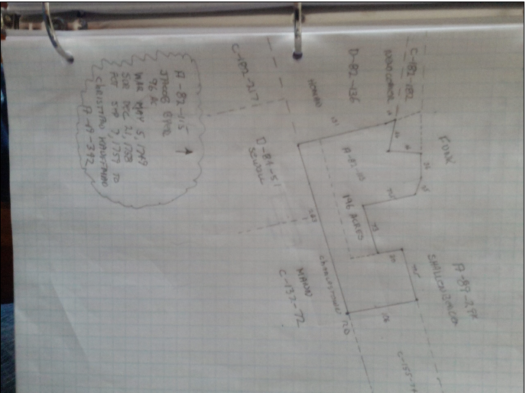

I looked at the maps of the area east of Washington Boro and saw this.
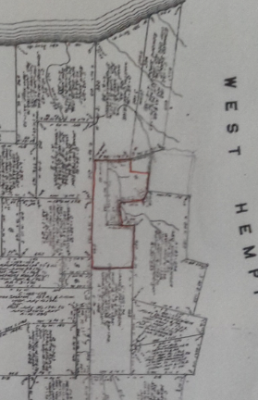
Then I looked at a modern day map of the area and saw this.
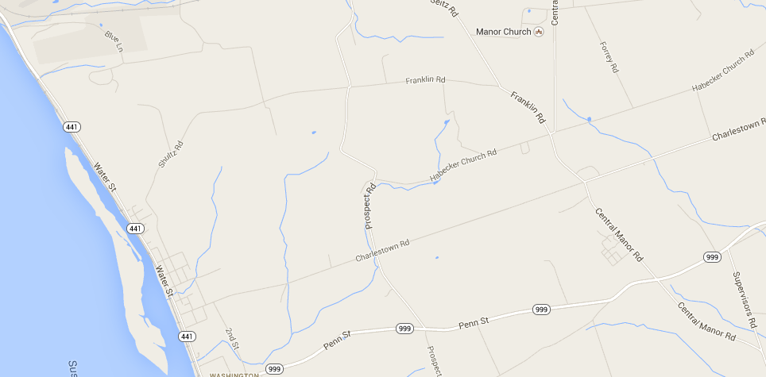
I was able to locate the property looking at modern GIS for Manor Township and find the property owner. The family was a two generation Mennonite family who had owned the farm for 40 years. They were gracious enough to invite us to the farm. 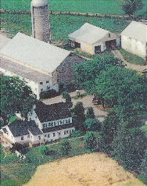

Amazingly their son had done a study of the history of the land for his high school project and we uncovered a treasure trove of information. But also we discovered the head stone of Isaac Baer Kauffman which had been plowed up by the previous owners. I did not find Christian Kauffman’s burial spot but I did find his son. 